 | Mathematics Essential  Test 4, 2015  Topics - Graphs |  | 40  = %
Total Time: | 45 minutes
Total Reading: | 5 minutes
Total Working: | 40 minutes
Weighting: | 5% of the year.
Equipment Allowed: | Calculator
You must include all working out to receive full marks

CALCULATOR ASSUMED
- (5 marks:1, 1, 1, 2)
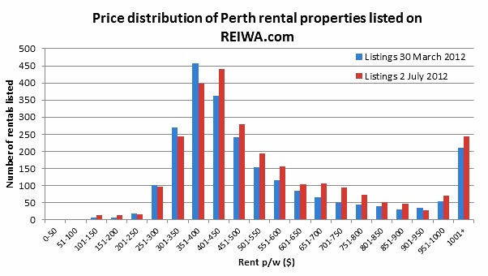

  - From the above graph what is the lowest rent per week?________________
  - What is the highest rent per week?_________________________________
  - Which rent bracket has the most number of rentals?____________________
  - Explain why the $1001 + rent p/w column has a sharp increase compared to the previous columns.___________________________________________
_______________________________________________________________
_______________________________________________________________
- (8 marks:1, 1, 2, 2, 2)

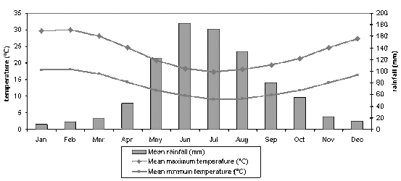

  - What is the mean maximum temperature in September?__________________

  - Which month has the coldest mean minimum temperature?_______________

  - What is the difference between the mean maximum and mean minimum
temperatures in May?_____________________________________________

  - How much more rain falls in June than December?______________________

  - Describe the annual rainfall pattern?_________________________________
_____________________________________________________________________________________________________________________________________________________________________________________________

- (10 marks;7,1,1,1)

56 children were asked which of the following hobbies they prefer. Their results are recorded in the table below.

 | Computer games | Watch Films | Read | Total
Girls | 5 |  |  | 22
Boys |  | 11
Total | 24 |  | 10

- Complete the missing values

- How many boys prefer computer games?

- What percentage of children watched films?

- What percentage of girls read books?
- (6 marks)
The following data set shows the temperatures over 1 day.

Time | Noon | 3pm | 6pm | 9pm | Midnight | 3am | 6am | 9am | noon
Temperature | 30C | 33C | 30C | 29C | 25C | 23C | 22C | 28C | 32C

Draw an appropriate graph for this data

- (4 marks)

Police recorded the average number of people caught drink driving on the same section of road on different nights of week.

Monday | 5 | Tuesday | 6 | Wednesday | 4 | Thursday | 10
Friday | 12 | Saturday | 17 | Sunday | 8

Represent the above information as a pictograph. Use a bottle to represent two people.

- (4 marks: 1, 1, 2)

This stem and leaf plot shows the scores of students in a class.
- How many students took the test?

- How many students got a score of 60?

- How many students got a score less than 50?

- (3 marks)

Construct a stem and leaf plot to show the following.

